1️⃣ What is String data in Java?
In Java, string data means a sequence of characters like:
"Java"
"Hello"
"123"

Java provides three main classes to work with string data:
Class | Package | Nature
String | java.lang | Immutable
StringBuffer | java.lang | Mutable + Thread-safe
StringBuilder | java.lang | Mutable + Not Thread-safe

🔹 Immutable (with example)

String s = "Java";
s.concat(" World");
System.out.println(s);

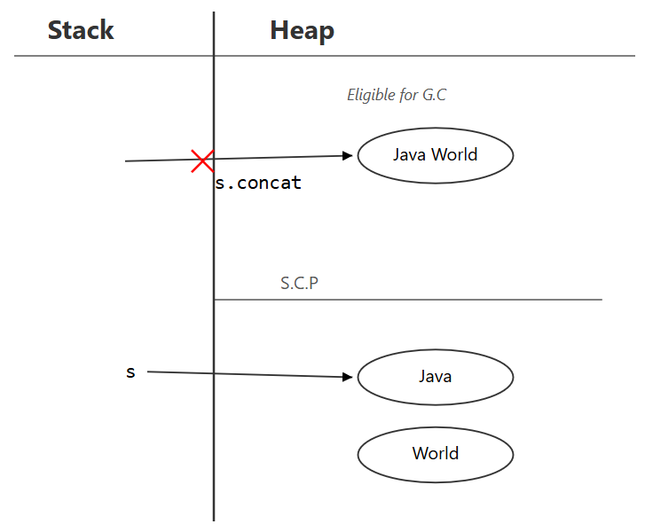

Step 1: Literal creation
String s = "Java";
- JVM checks SCP
- "Java" not found → created in SCP
- s points to SCP object
✔ No heap object created so far
SCP:
"Java" ← s

Step 2: Method call
s.concat(" World");

What actually happens internally:
- concat() is a runtime String operation
- The argument " World" is a String literal
  - JVM checks SCP
  - " World" is created in SCP if not already present
- concat() creates a new String object whose content is "Java World"
- Since this is a runtime operation, the result String object is created in the Heap
- The method returns the reference to this new heap object
- You do not store the returned reference

Important clarification (THIS IS THE POINT YOU ASKED FOR)
Even though the String literal " World" exists in SCP,
and even though "Java World" is composed using literals,
the result of a runtime String operation is a NEW String object created in the Heap.
No reference points to an SCP object for the runtime result unless explicitly interned.

So now memory looks like this:
SCP:
"Java" ← s
" World" (literal, may exist without reference)

Heap:
"Java World" (no reference) → GC eligible
✔ Yes, a new object is created
✔ Yes, it is a heap object
✔ Yes, it is unreferenced
✔ Yes, it is eligible for Garbage Collection

Step 3: Print
System.out.println(s);
- s still points to SCP object "Java"
- Heap object "Java World" was never assigned
- Output:
Java

🔑 Important distinction (DO NOT MIX THESE)
Case | Where object is created
"Java" | SCP
"Java" + "World" (compile-time) | SCP
s.concat("World") (runtime) | Heap
new String("Java") | Heap

⭐ FINAL CORE NOTE (ADD THIS TO YOUR NOTES)
In runtime String operations, even if String literals are involved and exist in SCP, the result String object is created in the Heap.
SCP literals may exist without references, but the runtime result reference always points to the heap object unless explicitly interned.

Eg2:
String s = "Java";
s = "Java World";

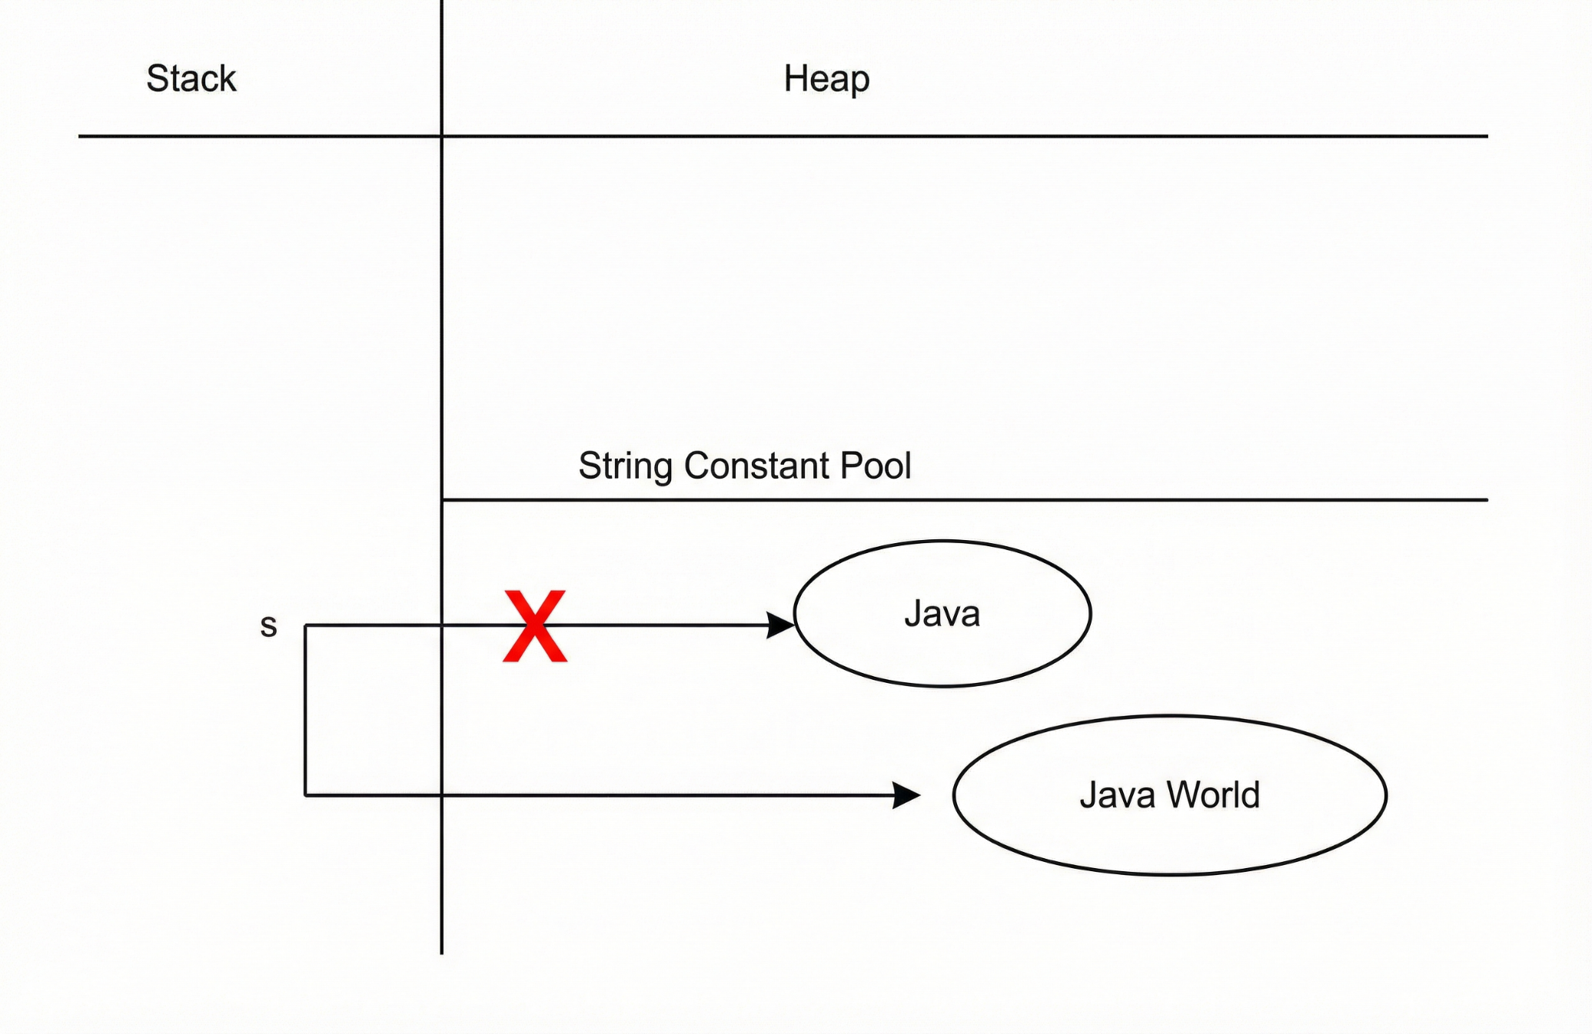

Here s is in stack. Thinking that it is local variable. The reference variable will be present based on the scope.

🔹 What happens internally (correct explanation)

1️⃣ String creation using double quotes " "
If a String is created using double quotes without the new keyword, the object is created only in the String Constant Pool (SCP).
✔ JVM first checks SCP
✔ If no object with same data exists, a new object is created in SCP
✔ No heap object is created

2️⃣ Reassignment with another String literal
s = "Java World";
What JVM does:
- JVM checks SCP for "Java World"
- If not found, JVM creates a new object in SCP
- Reference variable s is updated to point to this new SCP object
- The previous object "Java" loses the reference from s
✔ New object created in SCP
✔ Reference is reassigned explicitly

3️⃣ What happens to the old object?
- The constant pool lives as long as the class is loaded
So even though:
- s no longer points to "Java"
Still:
- The class metadata keeps "Java" alive
➡ Result:
❌ "Java" is NOT GC-eligible at this point

🔁 When DOES it become GC-eligible?
A String literal becomes GC-eligible only if:
- The class that defined the literal is unloaded
- No other live references (including intern table references) exist
👉 In most applications:
- Classes stay loaded for the JVM lifetime
- So literals stay alive for the JVM lifetime
Java does not provide any direct API to ask “is this String in heap or SCP?”
But we can prove it indirectly using ==, intern(), and behavior.
String a = "Java"; // literal → SCP
String b = a.concat(" World"); // runtime → HEAP
String c = "Java World"; // literal → SCP

System.out.println(b == c);
Output: false

Description of intern() method
Even though intern() is a runtime operation, it first checks the String Constant Pool (SCP) for an existing String with the same data. If such a String already exists, it returns the reference of that SCP object. If no such String exists, a new String object is created in the SCP and its reference is returned. The intern() method does not create any copy in the heap at all.
String s1 = new String("Java"); // heap
String s2 = s1.intern(); // SCP
String s3 = "Java"; // SCP

System.out.println(s1 == s3); // false
System.out.println(s2 == s3); // true

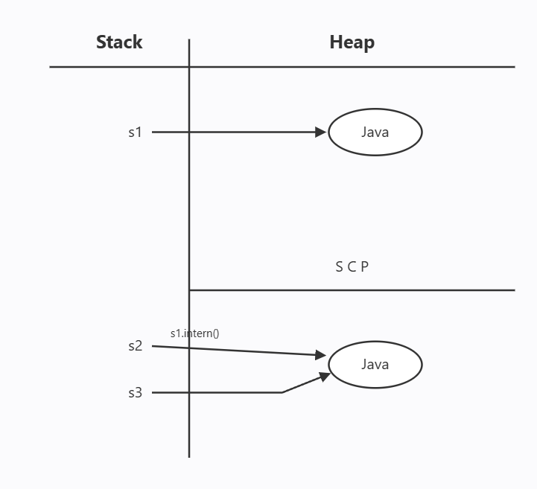

String s1 = new String("Java");
This statement creates a new String object in the heap and stores its reference in the variable s1.
The text "Java" is a String literal, so the JVM keeps one copy of it in the String Constant Pool if it is not already there.
Even though no variable directly points to this pool object, it is still kept alive because the class internally refers to it.

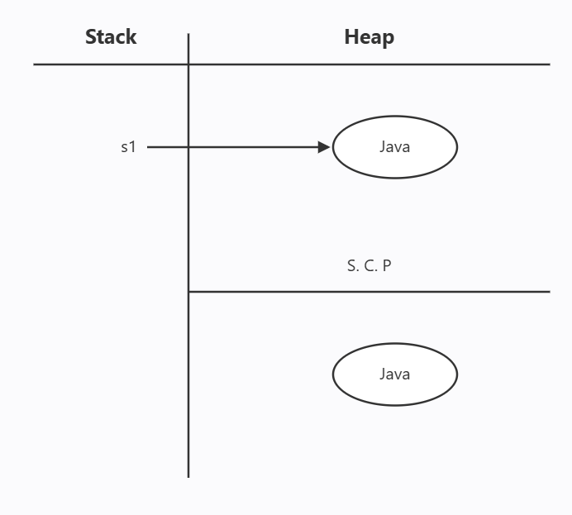

🔹 Mutable with StringBuffer (Example)

🔹 Mutable with StringBuffer (Example)
- StringBuffer objects are created only in the Heap
- The append() method modifies the same heap object
- StringBuffer does not use the String Constant Pool (SCP) for object storage
StringBuffer sb = new StringBuffer("Java");
sb.append(" World");
System.out.println(sb); // Java World

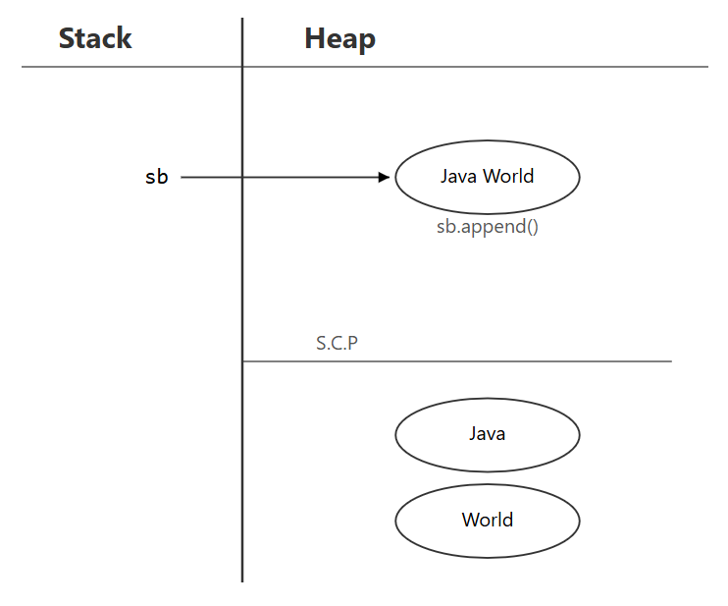

🔹 Step-by-step explanation
- The String literal "Java" is encountered
  - JVM checks the String Constant Pool (SCP)
  - If "Java" is not already present, it is created in SCP
  - This SCP object is not referenced by sb
- A new StringBuffer object is created in the Heap
- Characters from the SCP String "Java" are copied into the internal buffer of the heap object
- Reference variable sb points to the heap StringBuffer object
- append(" World") modifies the same heap object
  - No new object is created
  - No SCP lookup or reuse happens
- Reference sb remains the same
SCP:
"Java" (String literal, may exist without reference)

Heap:
StringBuffer(value="Java World") ← sb

✔ Final observations
✔ Content changed
✔ Object is the same
✔ Reference is the same
✔ SCP object (String literal) is never referenced
✔ StringBuffer object is always heap-resident

⭐ CORE NOTE (VERY IMPORTANT)
Even though a String literal used in a StringBuffer constructor may exist in the String Constant Pool, the StringBuffer object itself is always created in the heap and never points to SCP.

🔹 Mutable with StringBuilder (Example)
StringBuilder sb = new StringBuilder("Java");
sb.append(" World");

System.out.println(sb); // Java World
StringBuilder is mutable and heap-based.
append() modifies the same object in heap memory and does not use the String Constant Pool (SCP) for modifications.

✅ Explanation
• Works exactly like StringBuffer
• Content is modified in the same object
• Reference variable is not changed
• No new StringBuilder object is created during append()
sb ───▶ "Java World" (same object, modified)

⭐ Important point about the constructor String literal
Even though this is a StringBuilder, the constructor uses a String literal:
new StringBuilder("Java")
What happens internally:
- "Java" is a String literal
- String literals are always checked in the String Constant Pool (SCP)
- If "Java" is not already present, a new "Java" object is created in SCP
- This SCP object has no reference variable
- Then, a separate StringBuilder object is created in heap
- The content "Java" is copied from SCP into the heap object
- The reference sb points only to the heap object, not to SCP
SCP (no reference)
"Java"

Heap
sb ───▶ StringBuilder("Java") → append → "Java World"

🔑 Key Takeaway
• String literal "Java" may exist in SCP without reference
• Actual modifiable object is StringBuilder, created in heap
• append() changes only the heap object, SCP is never modified

🔹 Why StringBuffer & StringBuilder are Mutable
- They do not create new objects for modifications
- Methods like append(), insert(), delete() work on the same object
- Designed for frequent string modifications

🔹 Key Difference from String (Very Important)
Class | What happens on modification
String | New object is created
StringBuffer | Same object is modified
StringBuilder | Same object is modified

🔥 Key Rule (VERY IMPORTANT – memorize this)
Even when String literals are passed to StringBuilder or StringBuffer constructors, the literal is stored in SCP, but the builder/buffer object itself is always created in heap.

📌 Your code again
String s = "abc";
StringBuilder sb = new StringBuilder("efg");
StringBuffer sbf = new StringBuffer("hij");

🧠 What REALLY happens in memory (step by step)

1️⃣ String s = "abc";
✅ Correct
- "abc" is a String literal
- Stored in String Constant Pool (SCP)
- s points to SCP object
SCP:
"abc" ← s

2️⃣ StringBuilder sb = new StringBuilder("efg");
✔ "efg" is a String literal
✔ So "efg" IS created in SCP
❌ BUT sb does NOT point to SCP
👉 What happens internally:
- "efg" is placed in SCP (because it is a String literal)
- new StringBuilder("efg")
  - Creates a StringBuilder object in Heap
  - Copies characters from "efg" into its internal char array
- sb points to heap object only
SCP:
"abc"
"efg"

Heap:
StringBuilder(value="efg") ← sb

3️⃣ StringBuffer sbf = new StringBuffer("hij");
✔ Same logic as StringBuilder
SCP:
"abc"
"efg"
"hij"

Heap:
StringBuffer(value="hij") ← sbf

✅ So your statement (validated)
“abc is stored in SCP.
Since efg and hij are also literals, a copy is created in SCP.
But the actual objects referenced by sb and sbf are created in heap only.”

